[](http://www.google.co.uk/url?sa=i&rct=j&q=&esrc=s&frm=1&source=images&cd=&cad=rja&uact=8&ved=0ahUKEwiy05CZu8rLAhUFKQ8KHbqPBeQQjRwIBw&url=http://www.redlinebookfestival.ie/competitions&bvm=bv.117218890,d.ZWU&psig=AFQjCNFonAvK8txwj6V5mkZaDcxsKGEzNg&ust=1458398301291080)[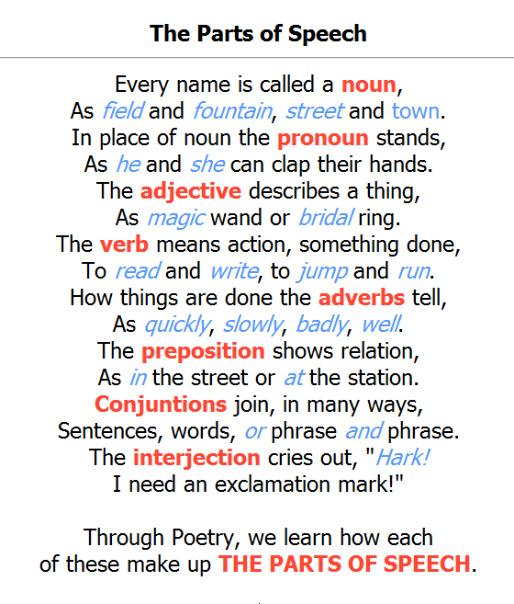](https://www.google.co.uk/url?sa=i&rct=j&q=&esrc=s&frm=1&source=images&cd=&cad=rja&uact=8&ved=0ahUKEwjY7K3as7bLAhVFLg8KHS4gBOIQjRwIBw&url=https://www.duolingo.com/comment/3324307&psig=AFQjCNGGJBl_0UIBHUGKes5prADAGeZ1CQ&ust=1457709099030650)